The Allegro Dance Company Liability Waiver and Acknowledgment of Risk:
READ AND SIGN BELOW
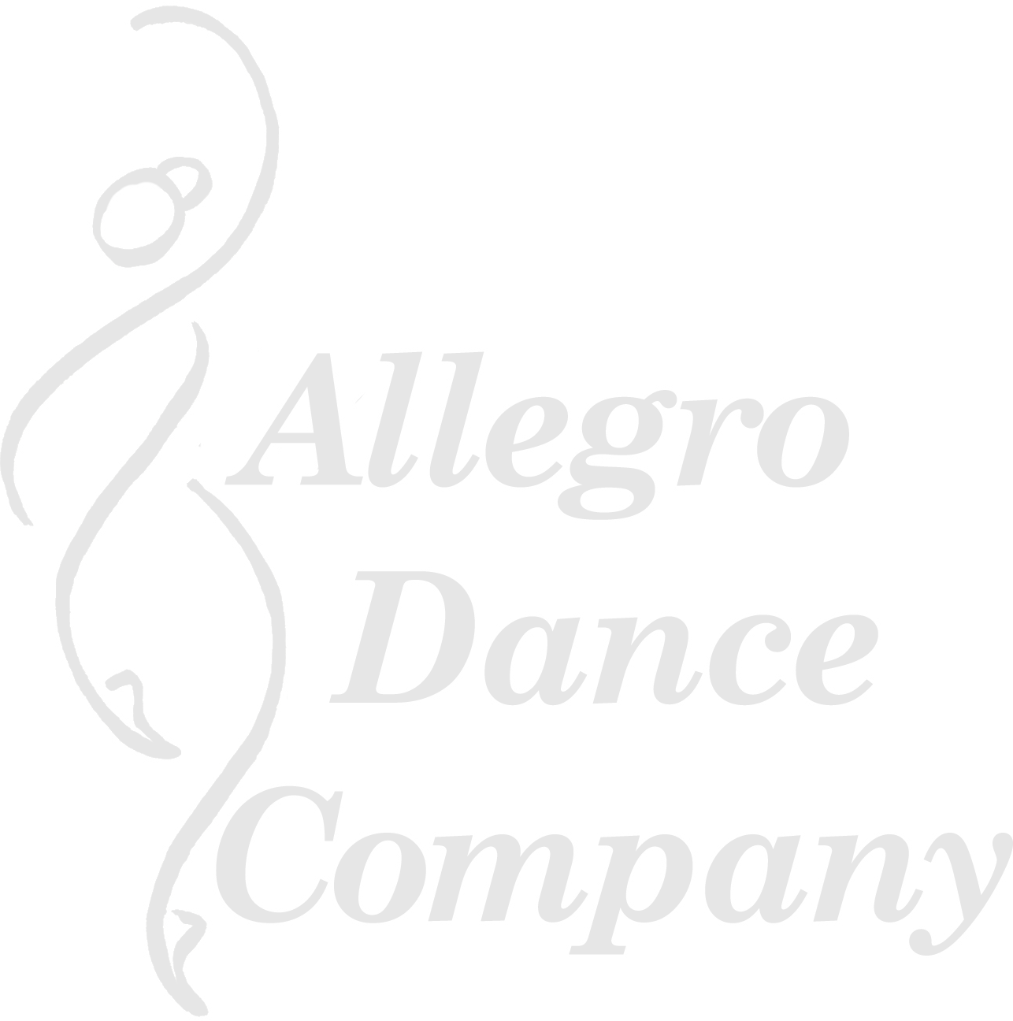
REGISTRATION IS INCOMPLETE WITHOUT SIGNATURE AND MUST BE COMPLETED BEFORE CLASS

I understand and agree that in participating in any dance class, workshop, rehearsal or performance, there is a possibility of physical injury or death. I voluntarily agree, therefore, to assume all risks and responsibility for any such injury or accident, which might occur to me or my child during any of Allegro Dance Company’s classes, rehearsals, performances, or activities. I also exempt, release, and indemnify Allegro Dance Company, its owners, agents, volunteers, assistants, employees, guest artists, faculty members, and/or students from any and all liability claims, demands, or causes of action whatsoever from any damage, loss, injury, or death to me, my children, or property which may arise out of or in connection with participation in any classes or activities conducted by Allegro Dance Company. I further hereby voluntarily agree to waive my rights and that of my heirs and assigns to hold The Allegro Dance Company, its owners, agents, volunteers, assistants, employees, guest artists, faculty members, and/or students liable for such damage, loss, injury, or death. I understand that I should be aware of my physical limitations and agree not to exceed them. If I am signing this waiver for my children, I certify that I am the parent or legal guardian and have the right to waive these rights.

Permission is granted Allegro Dance Company to use photographs of students for publicity purposes.

I have read, understood and agree to be bound by the above statement (please print your name, sign & date):

PRINTED:

SIGNED:
If under 18, parents or legal guardian must sign

FOR:
Name of Student

DATED:

